Lancaster Seventh-Day Adventist Church
A House of Prayer for All People

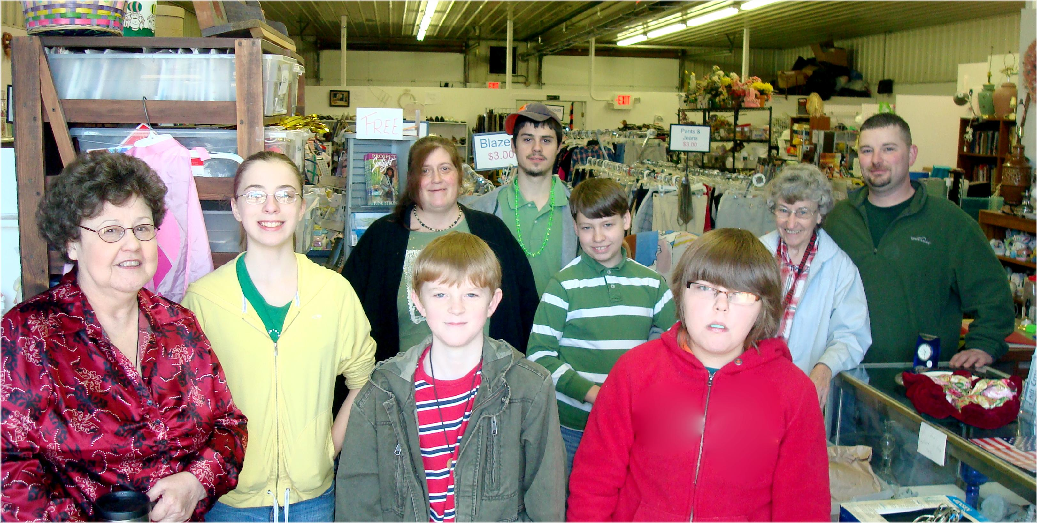

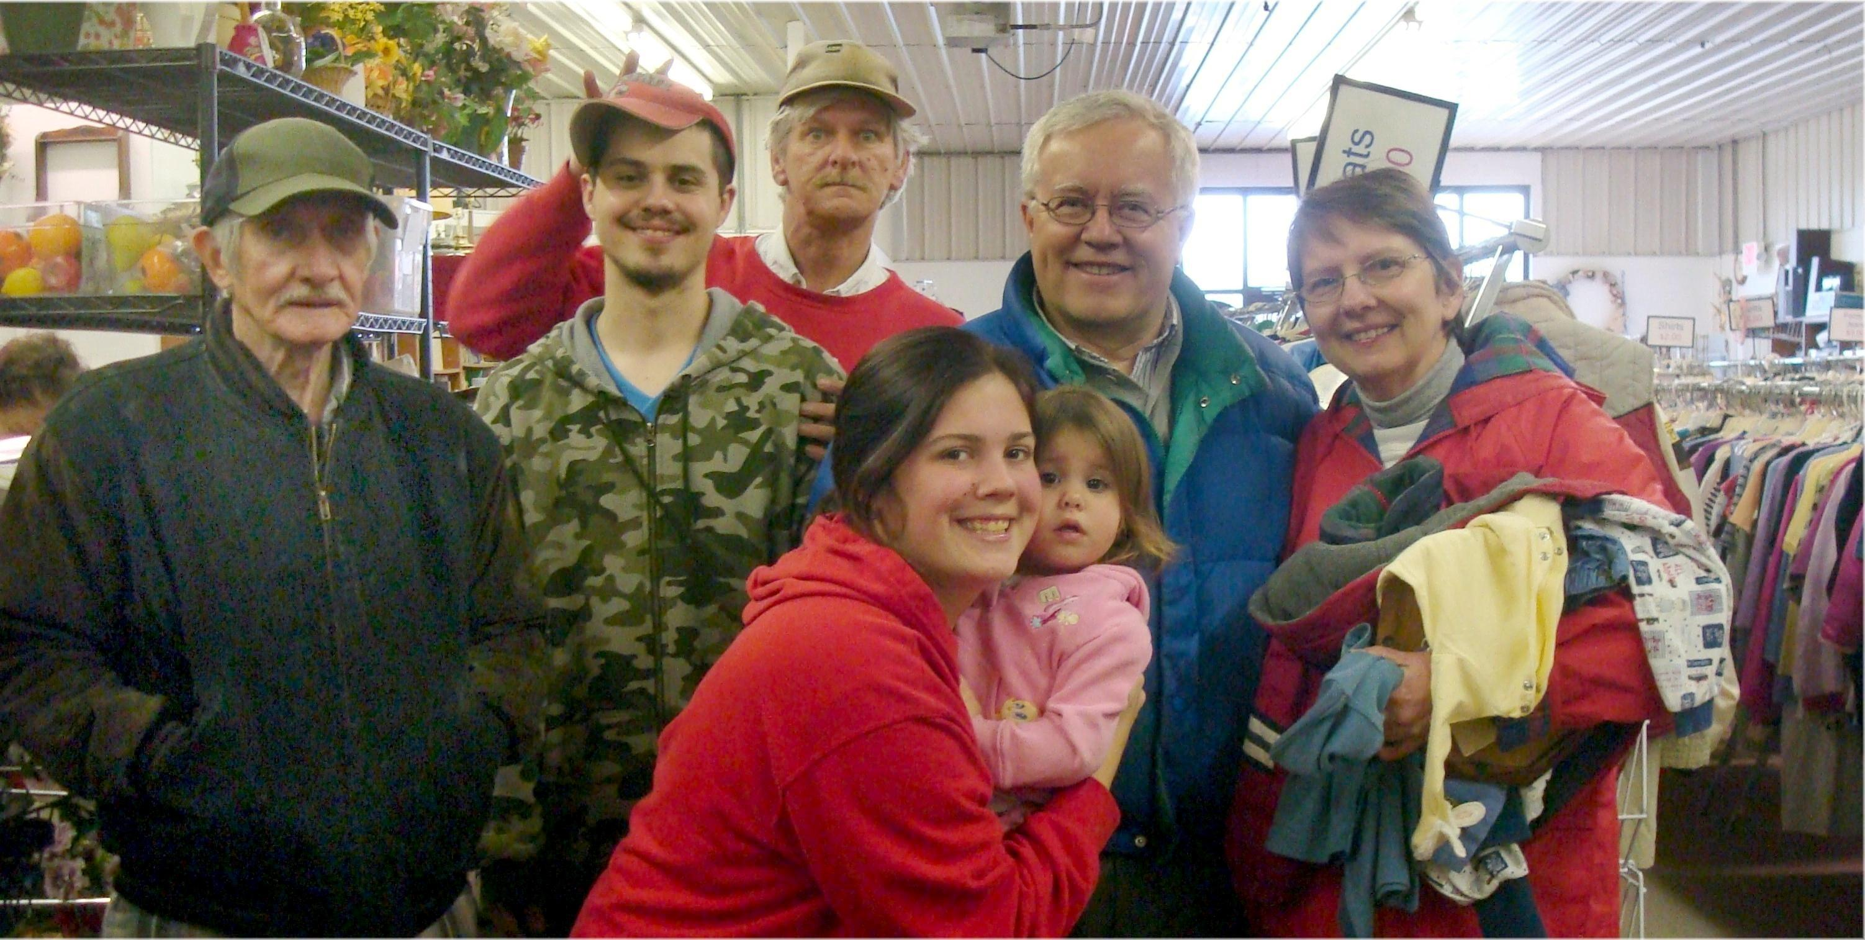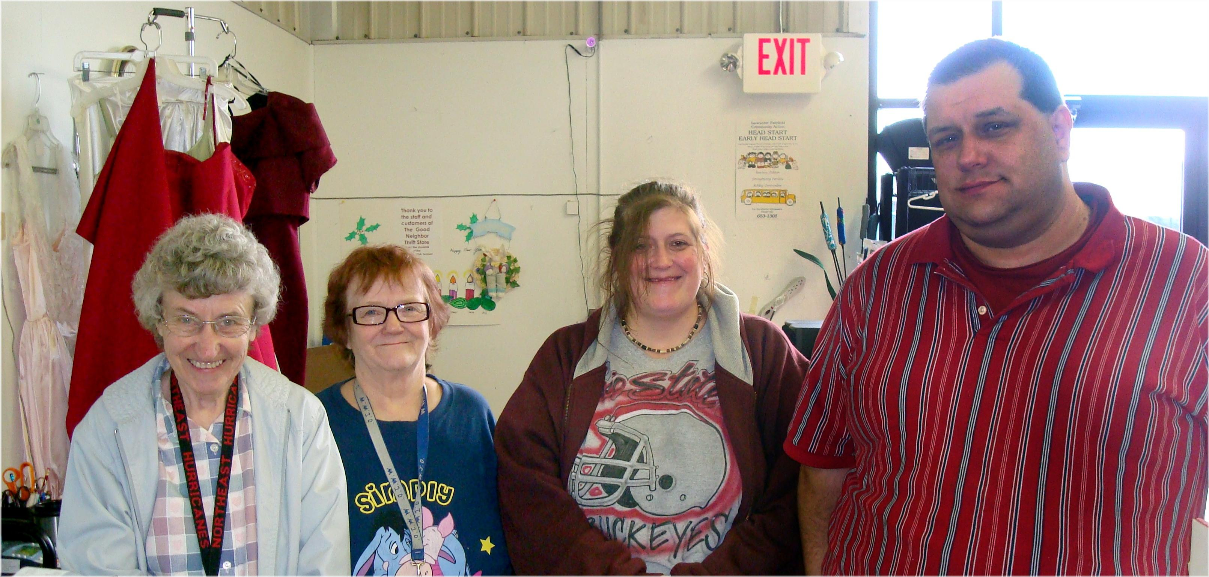
The New Good Neighbor Thrift Store 2nd Anniversary – May 1, 2010

