Lancaster Seventh-Day Adventist Church
A House of Prayer for All People

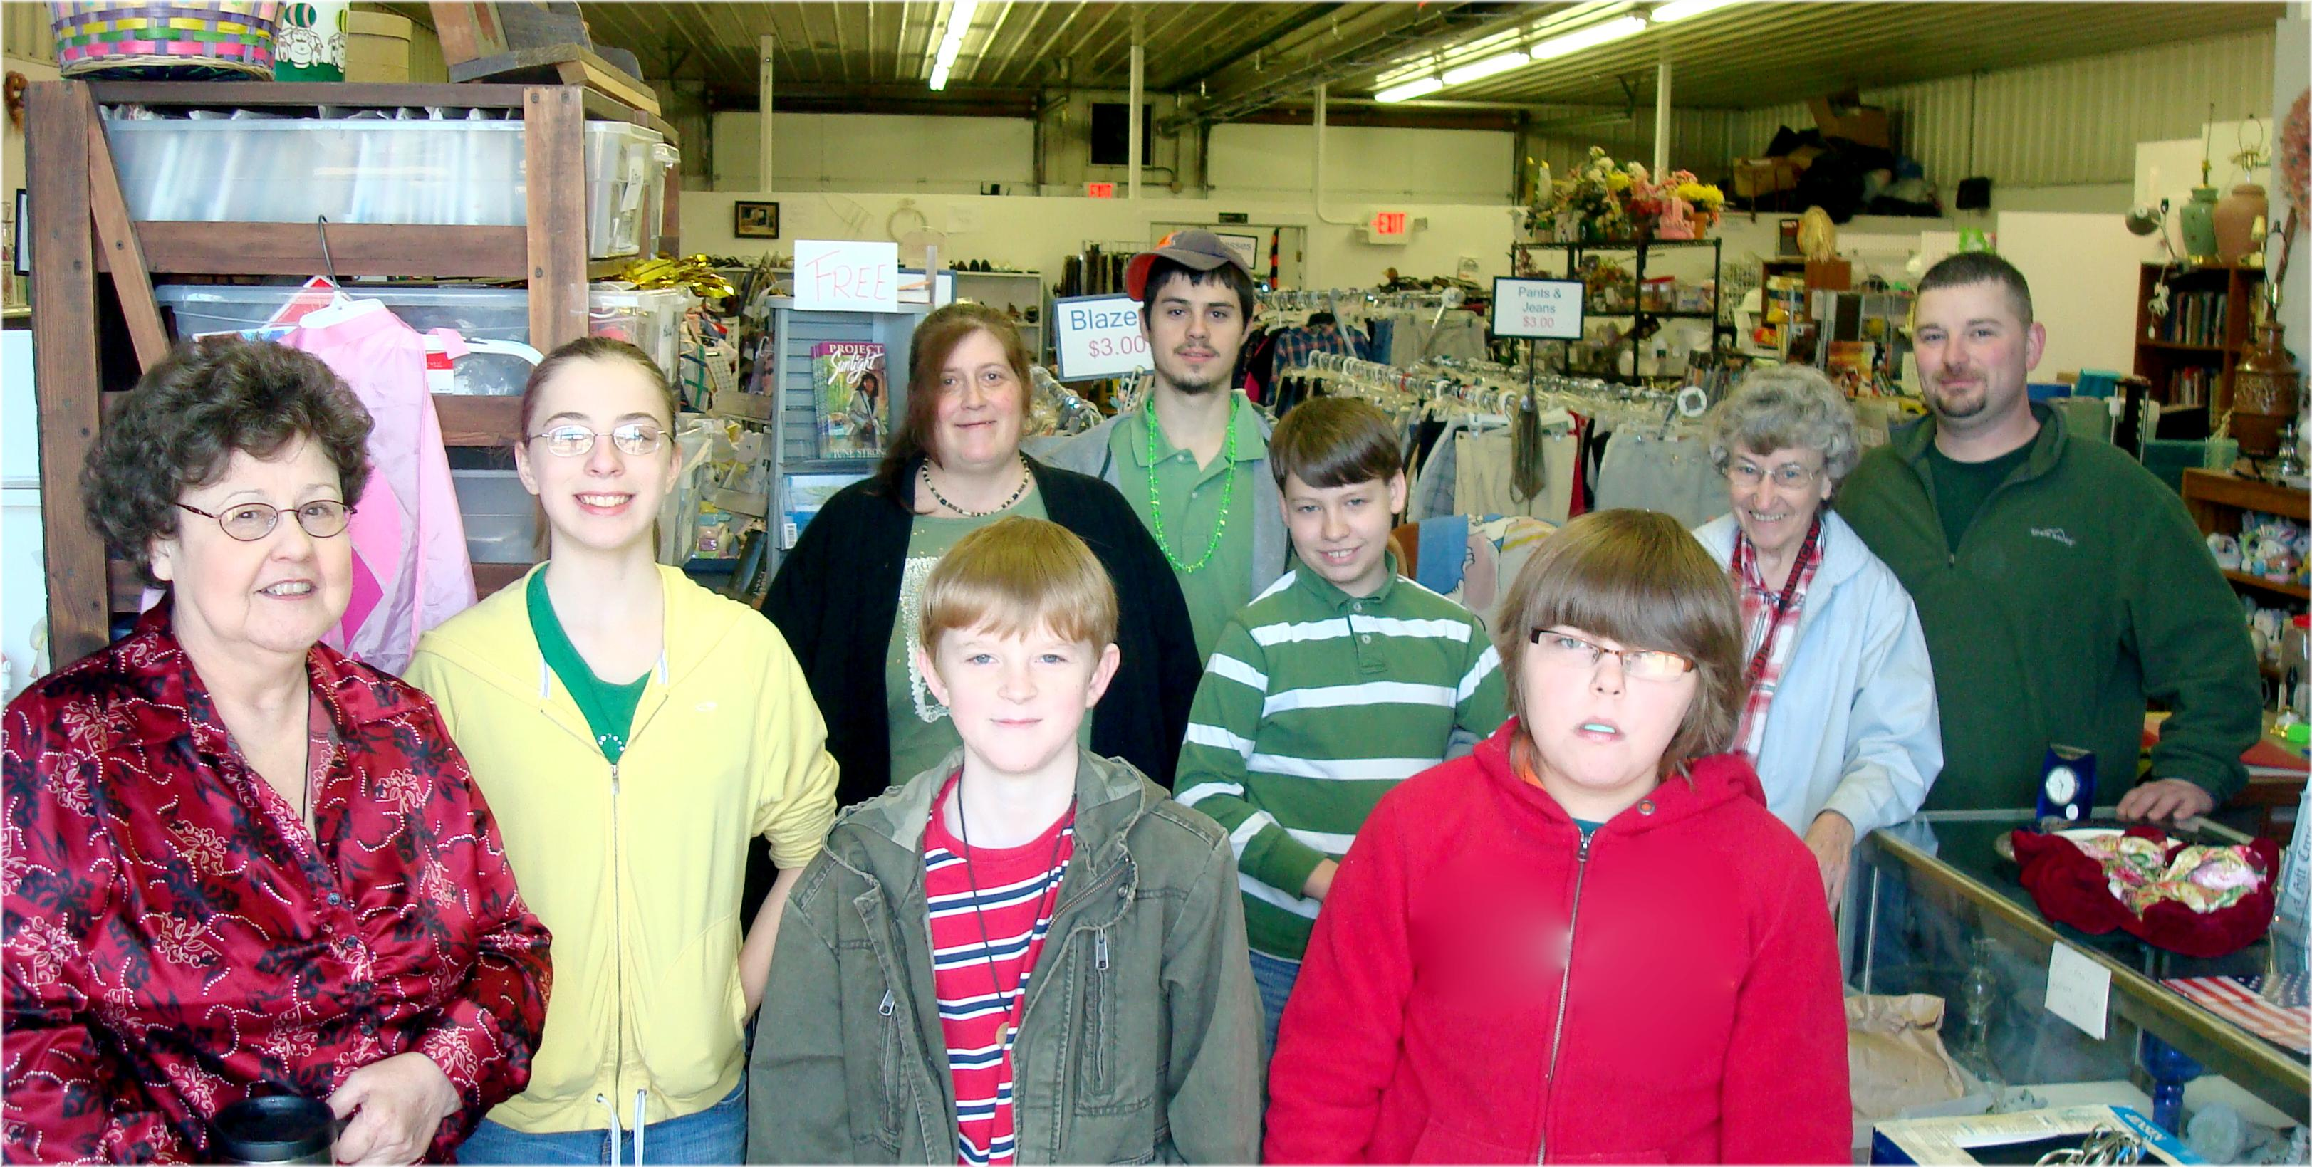
Not Pictured – Sandy, Karen, Darrell, Tami, Ralph, Carl, Jim, Allen, Al, Bonnie, Mary, etc.
Good Neighbor Thrift Store Volunteers - 2010

