Lancaster Seventh-Day Adventist Church
A House of Prayer for All People

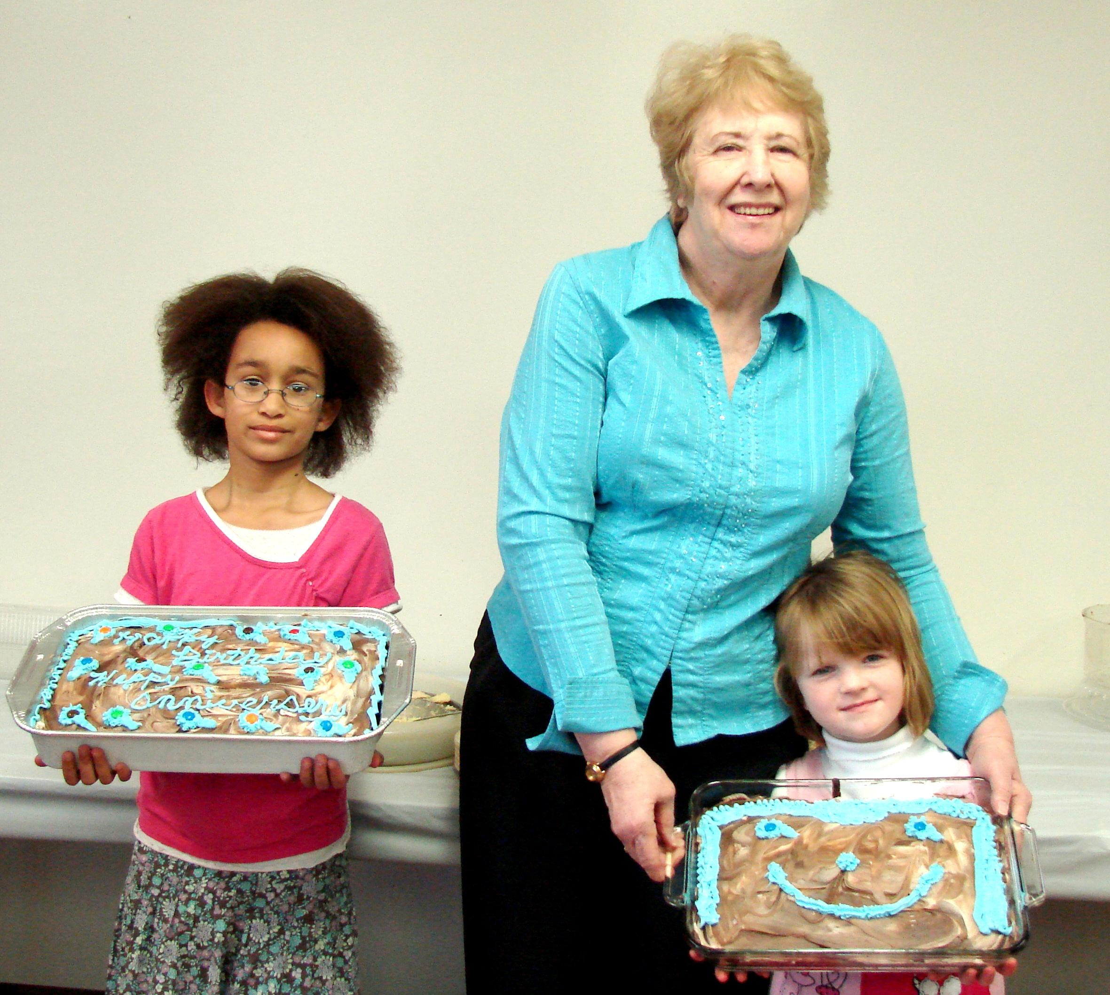
Summer and Rachael (with Diane)
March Birthdays - 2011

