Lancaster
Seventh-day Adventist Church
A House of Prayer for All People

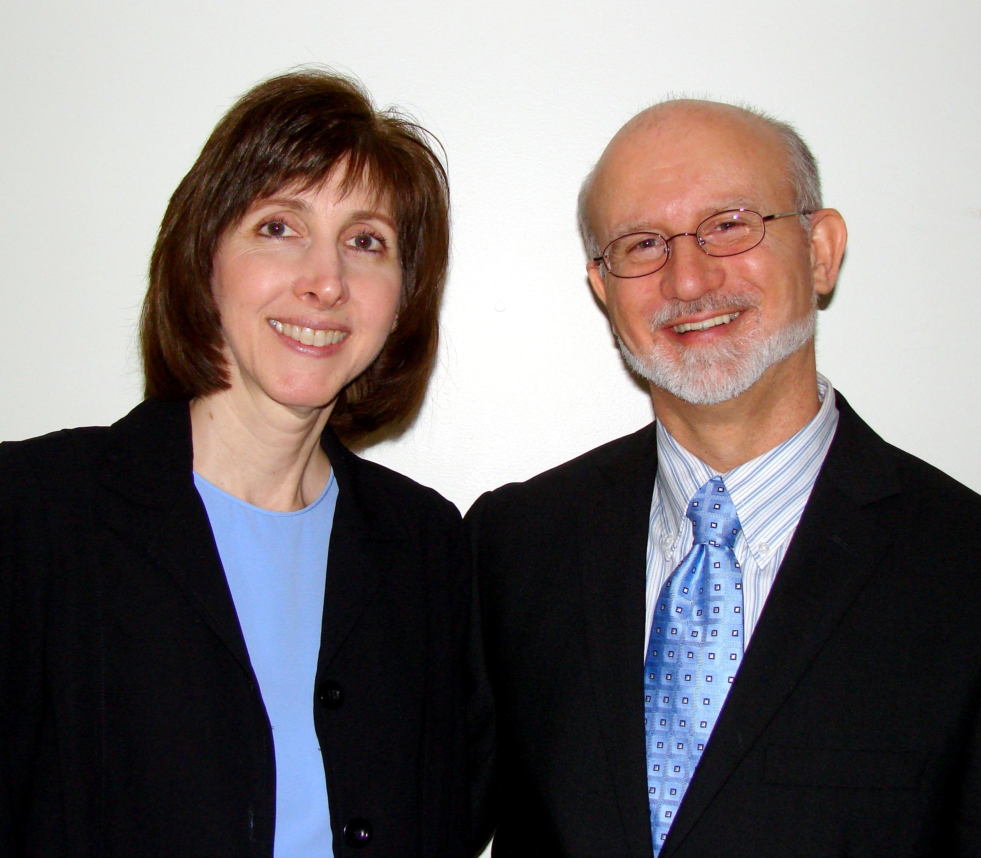

Welcome - Pastor Mike and Nancy Barnett – April 9, 2011

