Lancaster Seventh-Day Adventist Church
A House of Prayer for All People

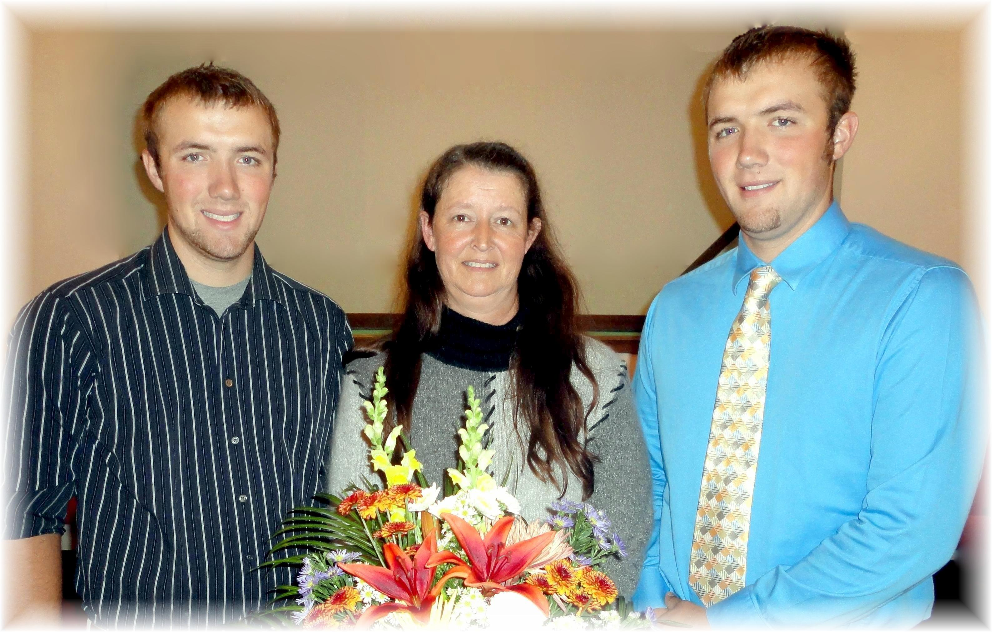
Nathan, Cyndee, and Ethan Mathias
Our Newest Members – September 24, 2011

