Lancaster Seventh-Day Adventist Church
A House of Prayer for All People
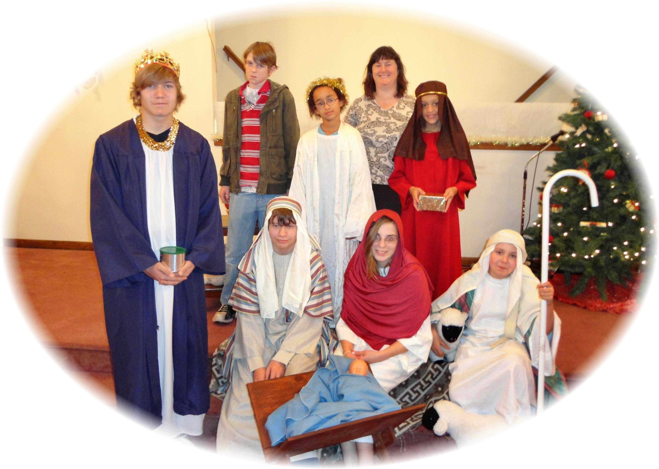
Church School Christmas Program - December 10, 2011

