Lancaster Seventh-Day Adventist Church
A House of Prayer for All People

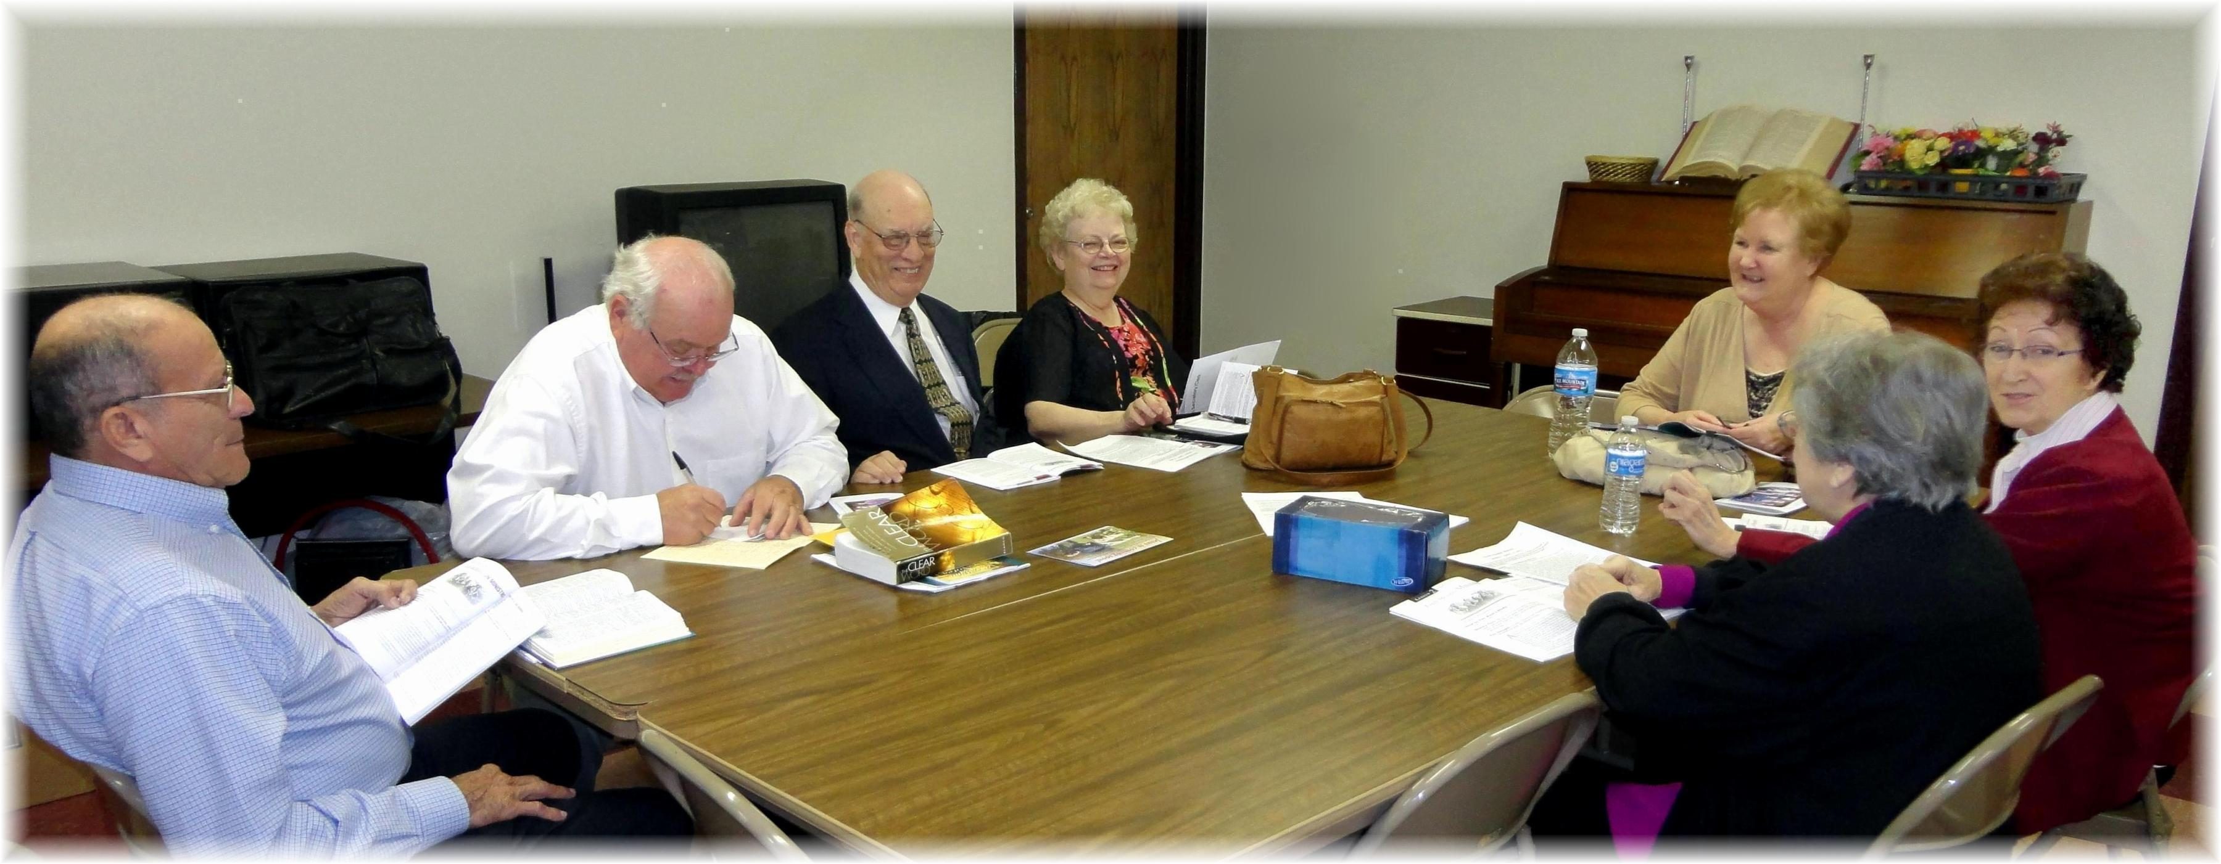
Around the table: Fidel, Darrell, Howard, Sandy, Linda, Alice, Josie
Adult Sabbath School Class – 2012

