Lancaster Seventh-Day Adventist Church
A House of Prayer for All People

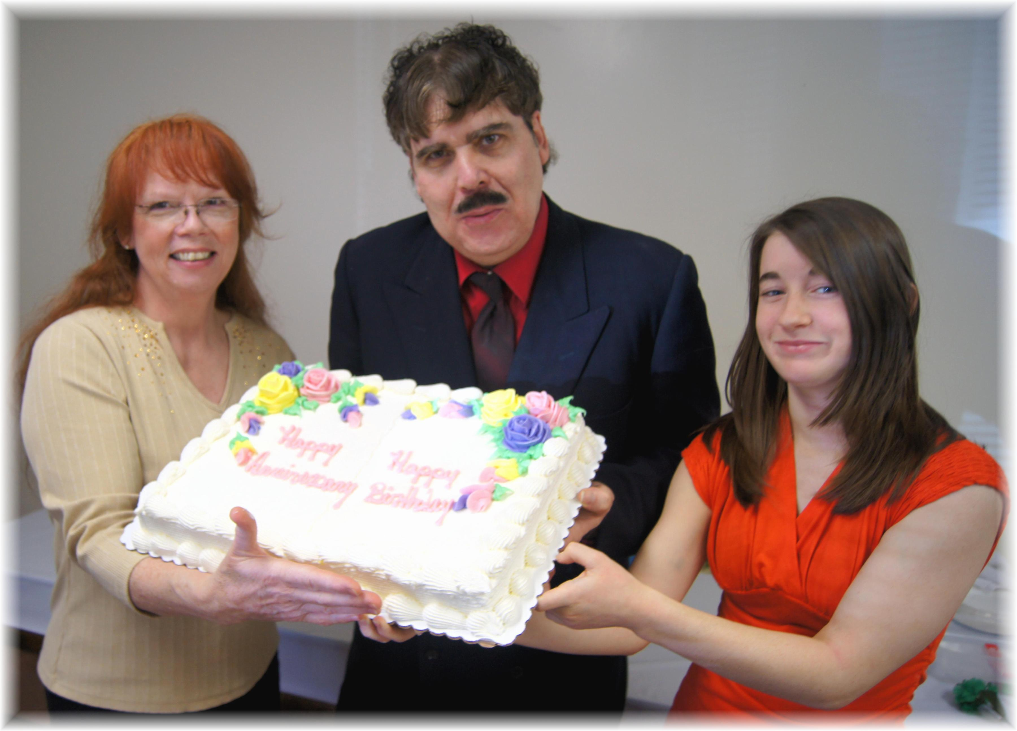
Barb, Carlton, Emily
March Birthdays - 2013

