Lancaster Seventh-Day Adventist Church
A House of Prayer for All People

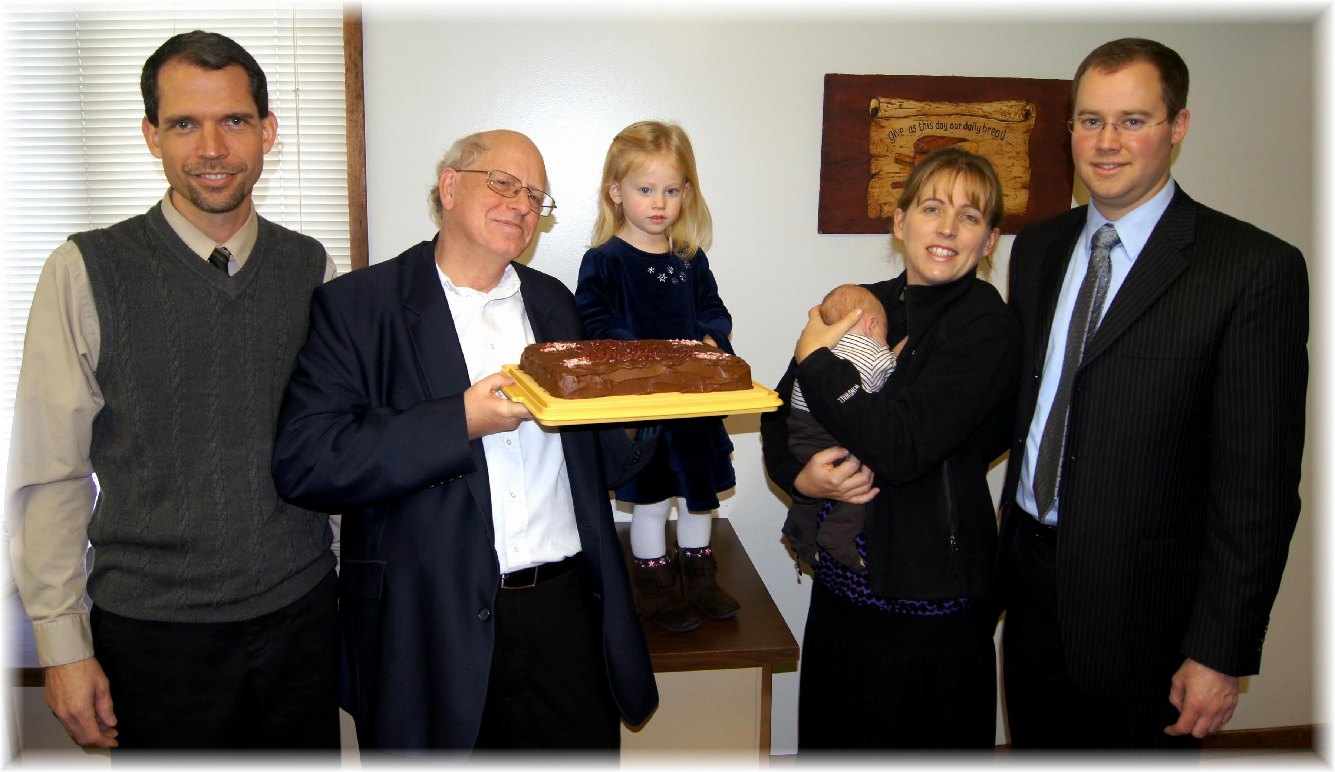
Birthdays: Travis, Bill, Chloe Anniversary: Marijke & Joel
December Birthdays and Anniversary - 2013

