Lancaster Seventh-Day Adventist Church
A House of Prayer for All People

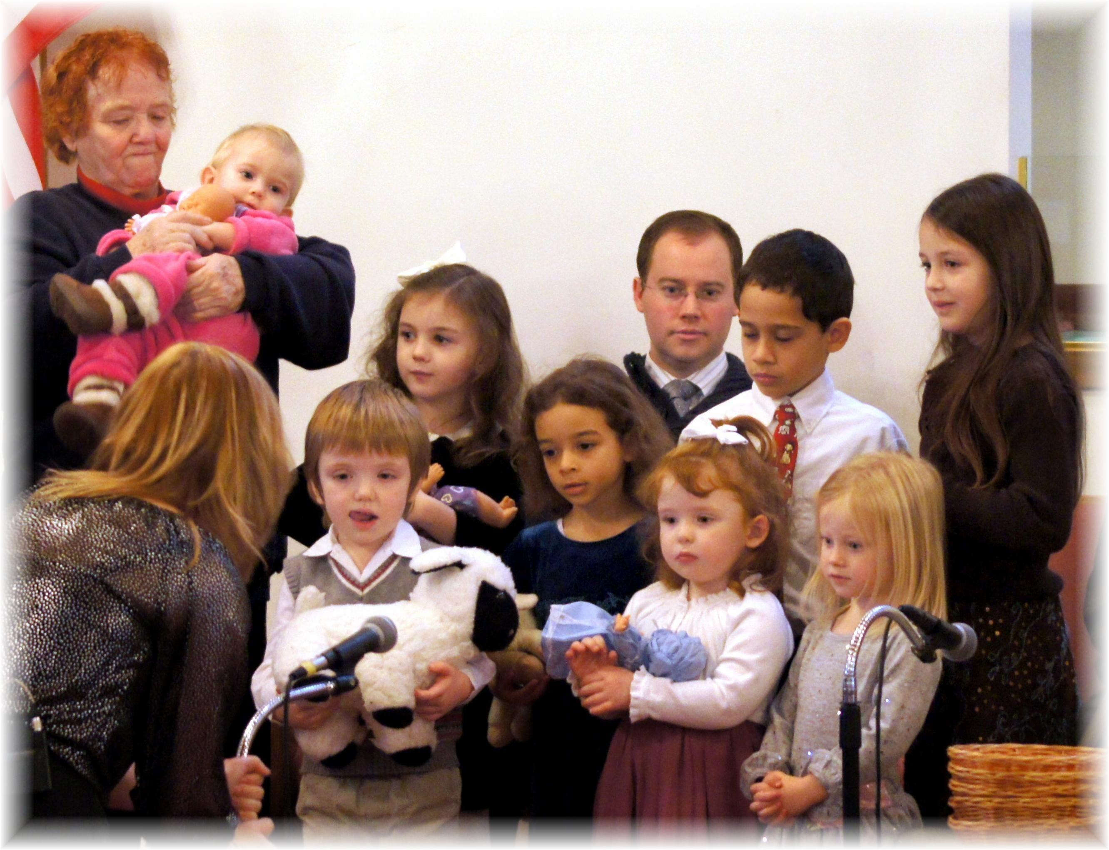
Children’s Special Music – December 14, 2013

