Lancaster Seventh-Day Adventist Church
A House of Prayer for All People

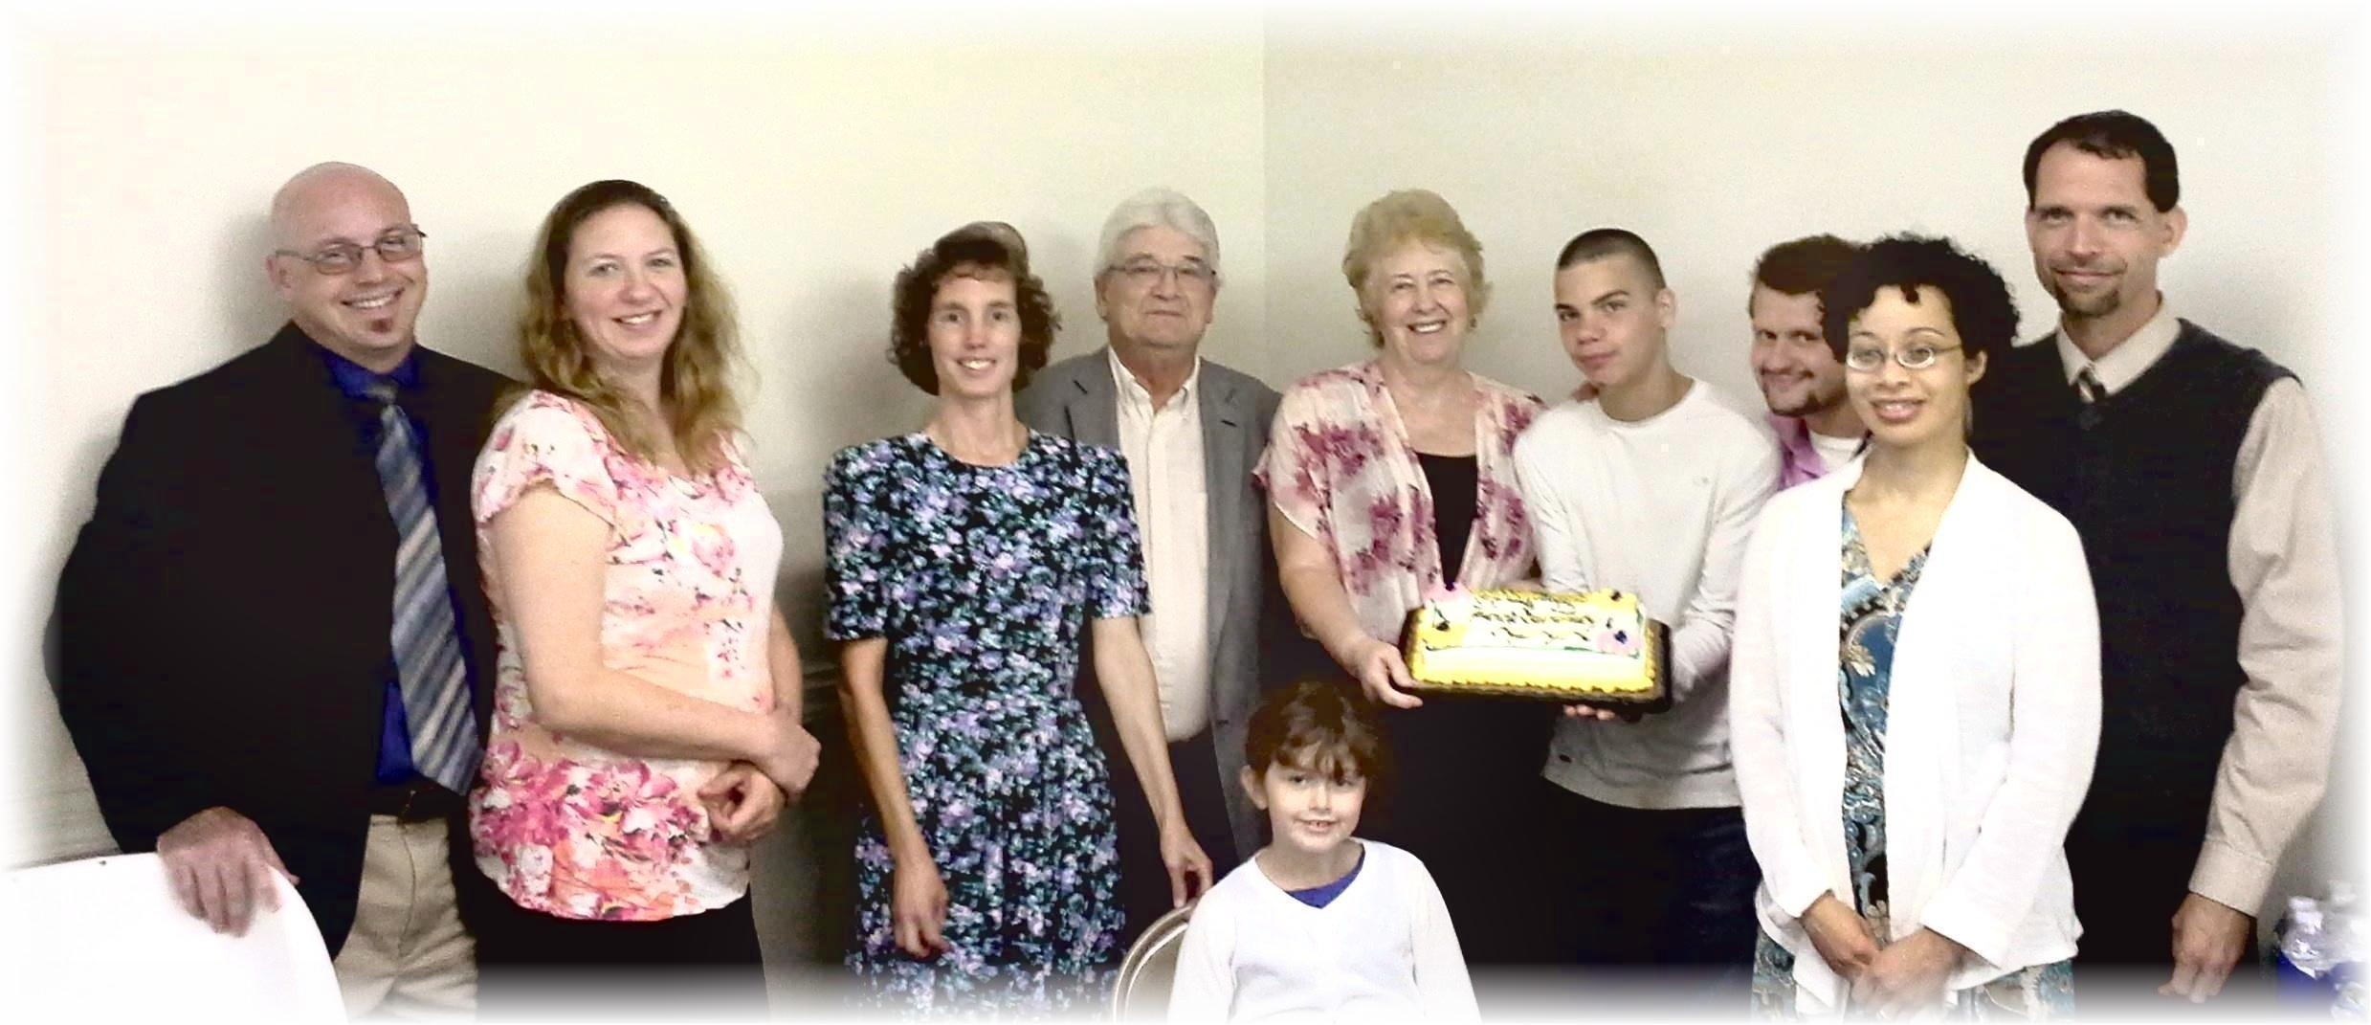
Anniversaries: Anthony & Jennifer (far left) Cesilia & Travis (far right)
Birthdays: Connie, John, Diane, Jacob, Allen, Ella (seated)
September Anniversaries and Birthdays - 2014

