Lancaster Seventh-Day Adventist Church
A House of Prayer for All People

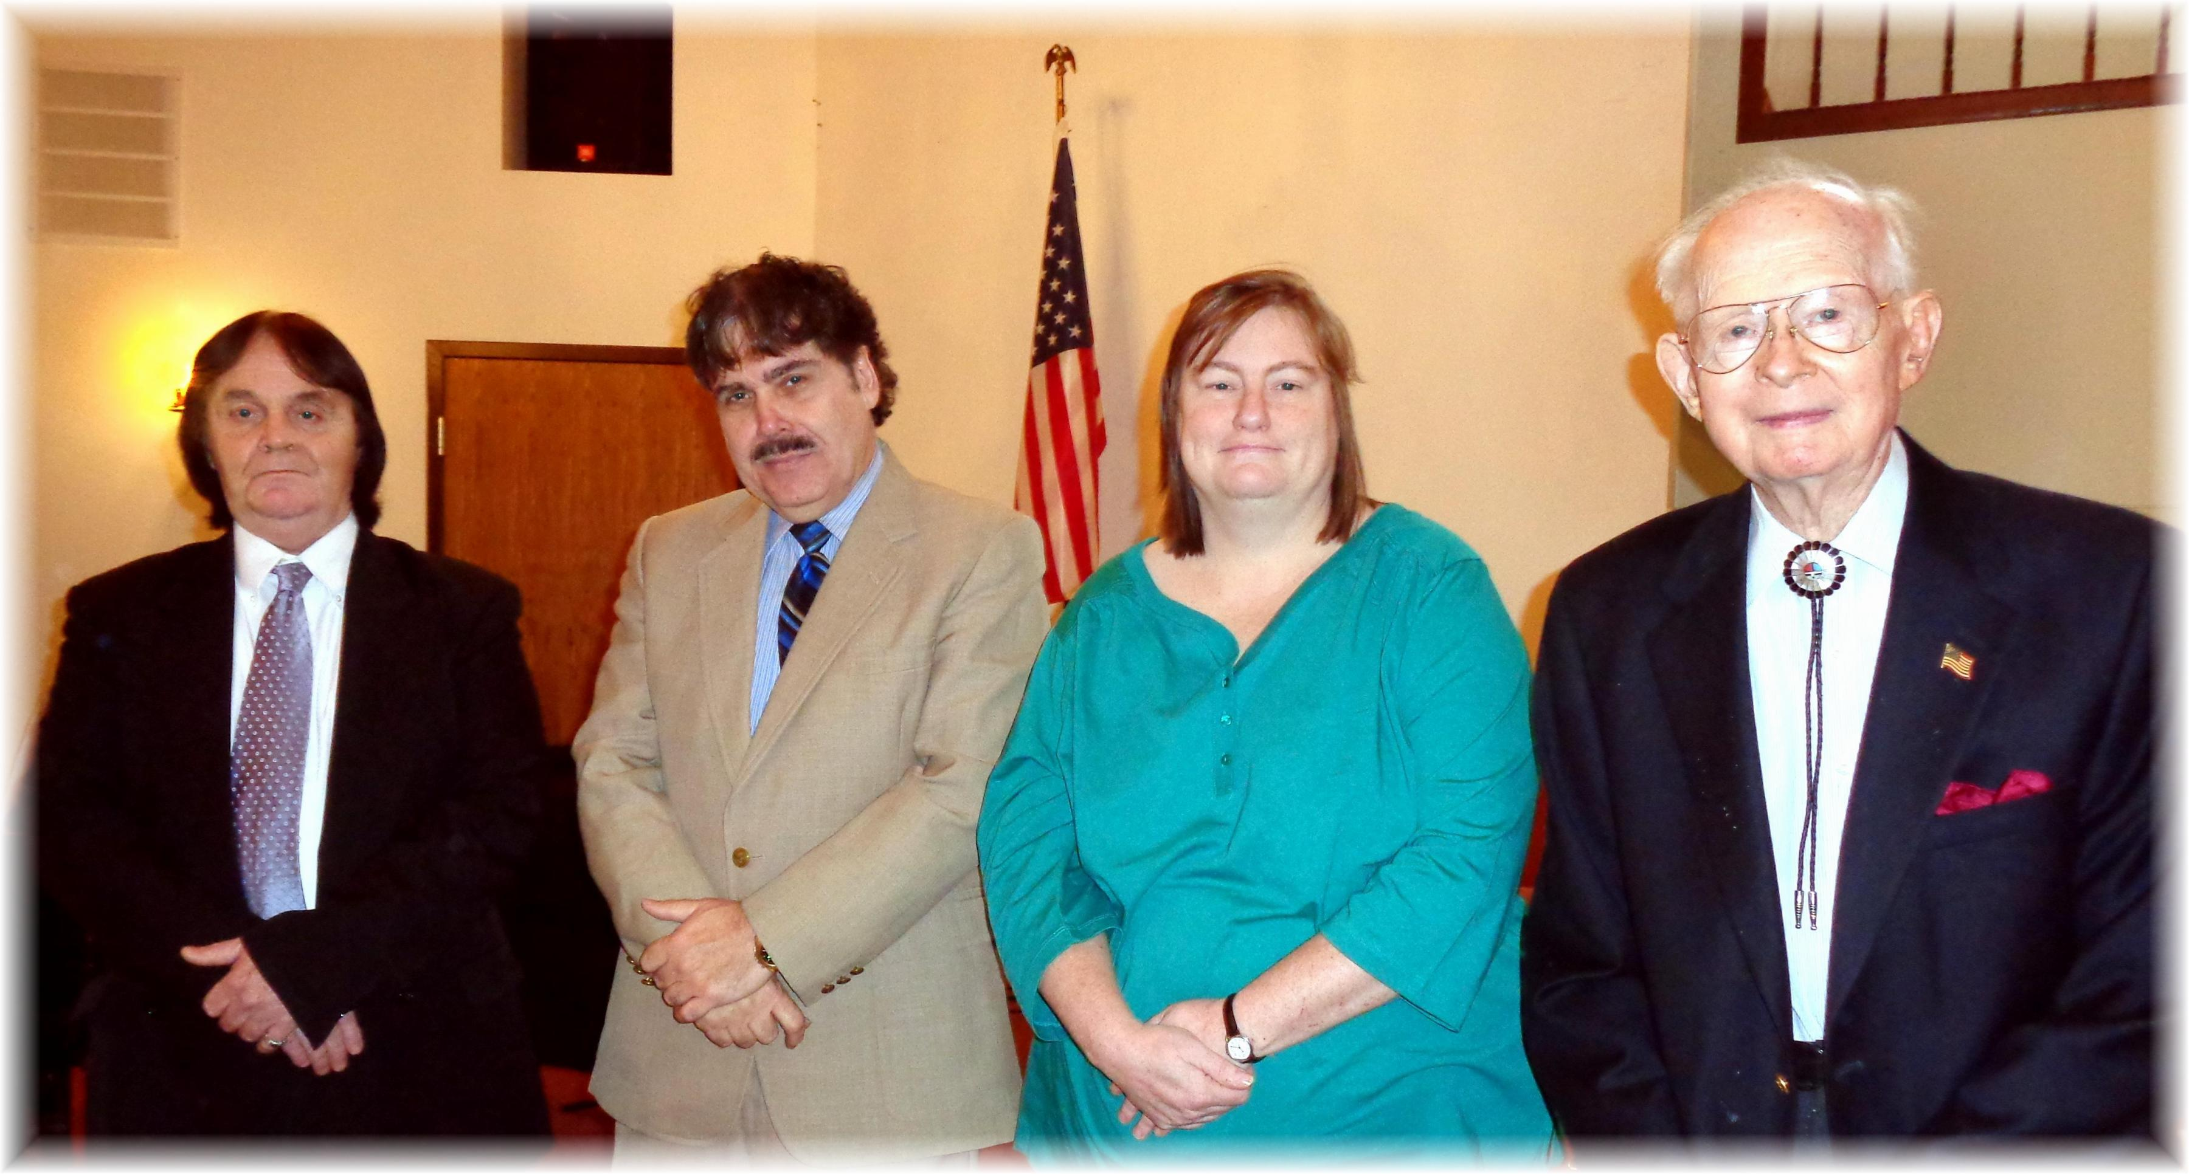
George Fields, Carlton DeNune, Stacey Hemmingway, Ralph Aldenderfer
Veterans Day – November 2014

